1 ) Designinig : -

First we add kernel calls and after syscalls and after in process managers we add all things

Just follow read me and attacted files which is useful to implemeted this system calls

This is the screenshot for the 10 clients because 10 trapcounter is incremented .

Now this is the another screenshots for 110 clients we take 100 number of cliets for that and message is also shown in fig: -

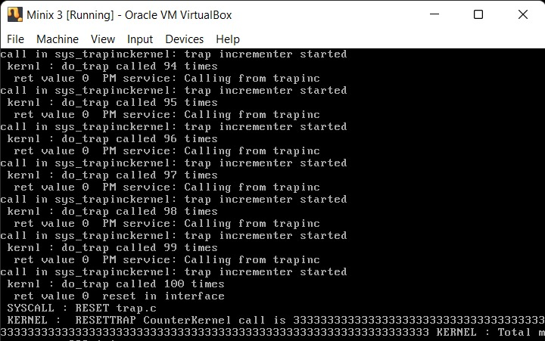

This graph will show the explanation of the data in clients vs traps :

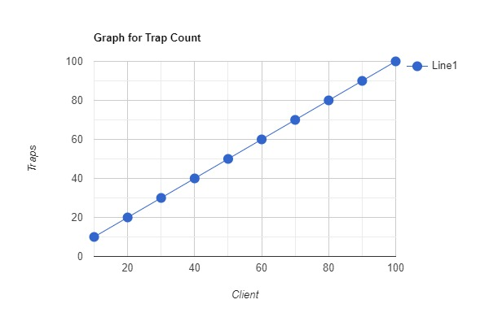

Another graphs will show the representation of the clients vs msg counter 